

Dear Volunteer,

Thank you for your continued support of Generation Scotland and providing a saliva sample. This sample will help us understand how genes and the world around us affects our health and wellbeing over time.

**INSTRUCTIONS**

Please **watch the video** at the web pagebelowbefore using the sample kit.



|  |  |  |
| --- | --- | --- |
| generationscotland.org/volunteer/sample | OR | Scan me: |

**What’s in my Saliva Kit?**

This box contains your sample kit. You should see all of these items pictured and labelled below. If any items are missing or damaged please contact us by email genscot@ed.ac.uk or phone **0131 651 8718**. Please keep the box safe as your sample will be returned in it.

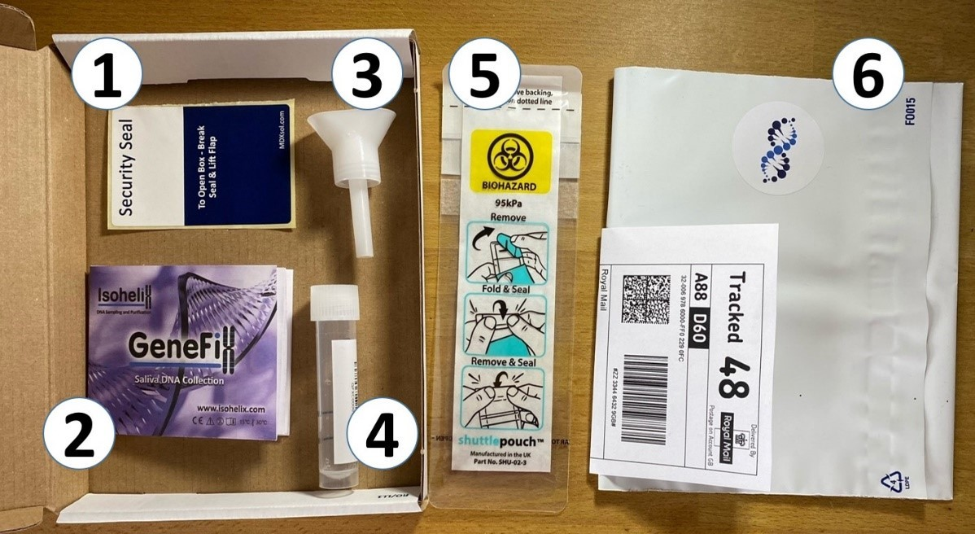

1. Security Seal for your box **(4)** Saliva collection tube
2. Instructions for your saliva kit **(5)** ‘Shuttle pouch’ bag for your saliva

sample in its tube

1. Funnel for your saliva sample tube **(6)** Prepaid return envelope for your box

The video will guide you, step by step, on how to take your sample.

Please **do not tear the bag** **(5)**, we open up your sample that way after you have posted it back to us.

You’ll notice the saliva collection tube **(4)** has a small amount of liquid already inside it. This is similar to a mild cleaning solution. It is there to protect your saliva until we receive it at the laboratory. If you spill the liquid, that’s OK. You can wipe it up like any other spillage. Please let us know and we will be happy to send you out another kit. If the liquid comes into contact with your skin please wash it with soap and water.

Contact us if you have any specific questions.

# Returning your sample

Once you have collected your saliva in the tube **(4),** place the saliva collection tube in the ‘shuttle pouch’ bag **(5).**

Seal it as shown on the shuttle pouch **(5).**

Place the shuttle pouch into the cardboard box that your sample kit arrived in.

Seal the cardboard box closed with the security seal **(1).**

Place the sealed box into the prepaid return envelope **(6).**

Post your saliva kit back to us by placing it in a **post box**.

Please **do not** take the sample kit to a post office.

It is important that you follow these steps carefully as it ensures your saliva gets to us safely.

If you require any support with the kit, or you are helping someone else, please visit our Saliva Sample page at the web page below.

**generationscotland.org/volunteer/sample**

Thank you for taking part.

Best wishes,

Generation Scotland

The University of Edinburgh, Western General Hospital, Crewe Road, Edinburgh EH4 2XU

Telephone: +44 (0)131 651 8718 **|** Email: genscot@ed.ac.uk **|** www.generationscotland.org

The University of Edinburgh is a charitable body, registered in Scotland, with registration number SC005336